# CHAPTER 1: INTRODUCTION

Groundwater is a vital resource supporting agriculture, industry, and domestic needs. However, its availability is increasingly under threat due to over-extraction and climate change. Traditional methods of groundwater detection, such as manual surveys and borewell drilling, are labor-intensive, costly, and often inaccurate in predicting groundwater presence across diverse terrains.

The **Groundwater Level Prediction System** leverages geophysical data, including resistivity and conductivity, alongside machine learning models to predict groundwater presence. By visualizing subsurface profiles in 2D, this system provides an intuitive understanding of groundwater distribution. This project aims to offer a scalable, data-driven solution to aid policymakers, environmentalists, and farmers in sustainable water resource management.

## 1.1 Overview

Water resources, especially groundwater, are vital for sustaining agricultural, industrial, and domestic usage. With rapid urbanization and changing climatic patterns, groundwater depletion has become a significant concern globally. Accurate prediction and monitoring of groundwater levels are essential for sustainable management and planning. The **Groundwater Level Prediction System** aims to predict the presence of groundwater using geophysical data, such as resistivity and conductivity. This system combines machine learning models with data visualization techniques to provide a comprehensive solution for groundwater detection and monitoring.

Key features of the system:

* **Data-Driven Analysis**: Utilizes geophysical measurements (resistivity and conductivity).
* **Machine Learning Models**: Predict groundwater presence.
* **Visualization**: Generates 2D subsurface profiles for intuitive understanding.

## 1.2 Existing System

Traditional methods for groundwater detection rely heavily on manual surveys, empirical models, and borewell drilling. These approaches are time-consuming, labor-intensive, and expensive. Moreover, they lack accuracy in areas with complex geological formations and cannot provide real-time insights. Manual borewell drilling often results in trial-and-error processes, leading to unnecessary costs and resource wastage. While theoretical models use historical data, they fail to account for local variations in soil and rock properties, limiting their predictive capabilities. Furthermore, these systems do not offer visual representations of subsurface profiles, making it difficult for stakeholders to make informed decisions. Overall, the existing systems are inefficient, costly, and lack the technological advancements needed for accurate and efficient groundwater prediction.

## 1.3 Problem Statement

Accurate groundwater level prediction is a complex challenge due to the variability in geological formations and limited availability of real-time data. Traditional methods such as borewell drilling and empirical models are inefficient, costly, and often fail to provide reliable results. Additionally, the lack of advanced visualization tools makes it difficult to interpret subsurface data, leading to poor decision-making in water resource management. This highlights the need for an automated, data-driven system that can predict groundwater presence with high accuracy and provide intuitive visual insights to assist stakeholders in sustainable groundwater management.

## 1.4 Proposed System

The **Groundwater Level Prediction System** addresses the limitations of traditional methods by leveraging geophysical data and machine learning techniques to predict groundwater presence accurately. The system preprocesses data such as resistivity and conductivity, trains predictive models, and generates 2D subsurface visualizations. These visual representations provide clear insights into groundwater distribution, aiding decision-making. Additionally, the system is designed to be scalable and user-friendly, offering real-time predictions and automated workflows for efficient groundwater management. By integrating advanced analytics and visualization, this system enables stakeholders to make informed decisions, optimize resource utilization, and ensure sustainable water management practices.

## 1.5 Need and Scope

The **Groundwater Level Prediction System** is essential for addressing the growing challenges of groundwater depletion and resource mismanagement. Accurate and timely predictions of groundwater levels are crucial for farmers, urban planners, and environmentalists to make informed decisions about irrigation, water distribution, and conservation efforts. The system's ability to analyze geophysical data and provide real-time insights enhances resource planning and management. Its scope extends beyond local applications, offering scalability to different regions and terrains. By integrating machine learning and visualization, this system bridges the gap between data analysis and actionable insights, ensuring sustainable groundwater usage across diverse sectors. This system is crucial for:

* **Farmers**: Plan efficient irrigation schedules.
* **Urban Planners**: Design sustainable water distribution systems.
* **Environmentalists**: Monitor and prevent over-extraction of groundwater.

## 1.6 Report Organisation

* **Chapter 1** provides an overview of the **Groundwater Level Prediction System**, discussing the limitations of existing groundwater detection methods. It outlines the problem statement related to inaccurate and inefficient traditional techniques and introduces the proposed solution that leverages machine learning and visualization to address these shortcomings.
* **Chapter 2** presents the literature survey, detailing the background and foundation of the project. It describes the software engineering paradigm adopted (Agile Methodology) and explains the technologies used, including both software (Python libraries, Flask) and hardware requirements for building and deploying the system.
* **Chapter 3** focuses on the analysis of the system, identifying functional and non-functional requirements. It also includes a feasibility study, covering technical feasibility (tool compatibility and model accuracy), financial feasibility (cost-effectiveness of open-source tools), and operational feasibility (ease of system operation and maintenance).
* **Chapter 4** outlines the project planning, breaking down the development process into modules. It provides a timeline for each module, detailing the tasks and time required for data collection, model development, visualization, and deployment.
* **Chapter 5** describes the design of the system, including UML diagrams such as use case, class, and activity diagrams. It also covers the ER diagram and data flow diagrams, illustrating the interactions between various components and the overall system architecture.

# CHAPTER 2: REVIEW OF LITERATURE

## 2.1 Study

Several studies highlight the significance of geophysical data in predicting groundwater levels:

* **Resistivity**: Higher resistivity values generally indicate the absence of groundwater, as dry soil and rock formations exhibit greater resistance to electrical flow.
* **Conductivity**: Increased conductivity is often associated with the presence of groundwater, as water-laden soil and rocks allow better electrical conduction.
* **Machine Learning**: Advanced models such as regression and classification algorithms have demonstrated improved accuracy over traditional methods, making them reliable tools for groundwater prediction.

## 2.2 Problem Methodology

Numerous studies have underscored the pivotal role of geophysical data in groundwater detection and prediction. These studies emphasize the following key aspects:

* **Resistivity:** This parameter measures how strongly a material opposes the flow of electric current. Higher resistivity values are typically observed in dry geological formations, such as solid rock and dry sand, which often indicate the absence of groundwater. Conversely, areas with lower resistivity suggest the presence of water-bearing strata, making resistivity a critical indicator in groundwater exploration.
* **Conductivity:** Conductivity, the inverse of resistivity, measures a material’s ability to conduct electrical current. High conductivity is usually associated with saturated soil and rock formations, as the presence of water significantly enhances electrical conduction. This makes conductivity a reliable metric for identifying groundwater-rich zones, particularly in areas with high salinity or mineral content.
* **Machine Learning:** Machine learning models, such as linear regression, decision trees, and support vector machines, have been increasingly adopted in groundwater prediction. These models can analyze complex patterns in geophysical data, improving prediction accuracy compared to traditional empirical or deterministic methods. By leveraging large datasets, machine learning provides robust predictions and reduces the reliance on manual interpretations, offering a scalable and automated approach to groundwater analysis.

## 2.3 Software Engineering Paradigm

The Groundwater Level Prediction System adopts the Agile Software Development Paradigm, a flexible and iterative approach that ensures continuous improvement and adaptability throughout the project lifecycle. This paradigm is particularly well-suited for data-driven projects like this, where the requirements may evolve based on new insights and feedback.

**Key Features of Agile Methodology**

**1. Iterative Development:**

- The project is broken down into smaller, manageable modules, each developed in iterations (sprints).

- Each sprint focuses on specific functionalities, such as data preprocessing, model training, or visualization, allowing incremental progress and quick delivery of working components.

**2. Continuous Feedback:**

- Agile emphasizes frequent interactions with stakeholders (e.g., data scientists, researchers) to gather feedback at every stage.

- This helps refine the system based on real-world requirements and user expectations.

**3. Adaptive Planning:**

- Agile allows dynamic adjustments to the project plan. For instance, if a particular machine learning model does not perform as expected, the team can pivot to exploring other algorithms without disrupting the entire workflow.

**4. Cross-Functional Collaboration:**

- Agile fosters collaboration across different roles, such as developers, data analysts, and domain experts.

- This ensures that the system is developed with a holistic understanding of both technical and domain-specific requirements.

**5. Incremental Delivery:**

- Working features, such as model evaluation or visualization modules, are delivered incrementally.

- This provides stakeholders with usable components early in the development cycle, enhancing transparency and enabling early identification of potential issues.

**6. Continuous Testing and Integration:**

- Agile emphasizes automated testing and continuous integration to ensure the system remains stable and functional.

- Each new feature is thoroughly tested and seamlessly integrated into the existing system, reducing the risk of errors.

**Why Agile for This Project?**

The dynamic nature of geophysical data and the need for high accuracy in predictions make Agile an ideal choice for the Groundwater Level Prediction System. Agile’s iterative process allows the team to experiment with different machine learning models, optimize preprocessing techniques, and fine-tune visualization methods. Additionally, its emphasis on continuous feedback ensures that the system evolves in line with user needs and technological advancements.

By adopting Agile, the project benefits from:

* Flexibility in accommodating changes in data sources or modeling techniques.
* Scalability to integrate additional features, such as real-time data processing or advanced visualization.
* Efficiency in delivering a high-quality, user-centric solution for groundwater prediction.

## 2.4 Software Development Life Cycle

The Groundwater Level Prediction System follows the Agile SDLC model, which promotes iterative development and continuous feedback. The process begins with planning and requirement analysis, identifying system needs like data preprocessing, model development, and visualization. In the design phase, UML and data flow diagrams outline the system architecture. Implementation occurs in modular sprints, focusing on components such as data pipelines and machine learning models. Testing ensures system accuracy through unit and integration tests. After deployment, the system is monitored for performance and maintained with updates based on user feedback. This approach ensures flexibility, early delivery of functional modules, and alignment with user expectations.

## 2.5 Technology Methodology

* Frontend: The visualization component is built using Matplotlib to generate dynamic and interactive 2D subsurface plots for intuitive analysis.
* Backend: Flask is used to develop a lightweight and efficient backend, handling data preprocessing, model inference, and API requests.
* Database: Pandas DataFrames serve as the primary data structure for handling and processing geophysical datasets efficiently.
* Model Training: Scikit-learn is employed for machine learning, providing robust regression and classification models to predict groundwater levels.
* Visualization: Seaborn and Matplotlib are used to create detailed plots, including heatmaps and line charts, for subsurface groundwater analysis.
* Deployment: The system is deployed using Flask APIs, enabling real-time data interaction. It can be hosted on cloud platforms like AWS or Heroku for scalability and accessibility.

## 2.6 Hardware Requirements

* Development: A modern laptop/desktop with at least 8 GB RAM and a multi-core processor (Intel i5 or equivalent) to handle data preprocessing, machine learning model training, and running local development servers.
* Production: Cloud infrastructure such as AWS or Heroku for deploying the Flask API and ensuring scalable, consistent system performance.
* Database: Local data storage using Pandas DataFrames, with the option to use cloud-based storage solutions like Amazon S3 for larger datasets.
* Network: A reliable and fast internet connection for seamless data transfer, API deployment, and real-time visualization generation.

# CHAPTER 3: ANALYSIS

## 3.1 Identification of System Requirements

System requirements define the essential functions and features that the Groundwater Level Prediction System must fulfill to meet user needs. These requirements are categorized into functional, non-functional, and technical needs. The primary goal is to develop an integrated system that predicts groundwater levels using geophysical data and visualizes subsurface profiles. The system should support a range of operations, including data preprocessing, model training, and 2D visualization generation. It must handle large datasets efficiently, ensuring accuracy and reliability. Additionally, the platform requires a robust backend for data processing, a responsive visualization module for intuitive user interaction, and a secure API for real-time predictions. The system must also guarantee scalability to accommodate future enhancements and maintain high performance under varying workloads.

## 3.2 Functional Requirements

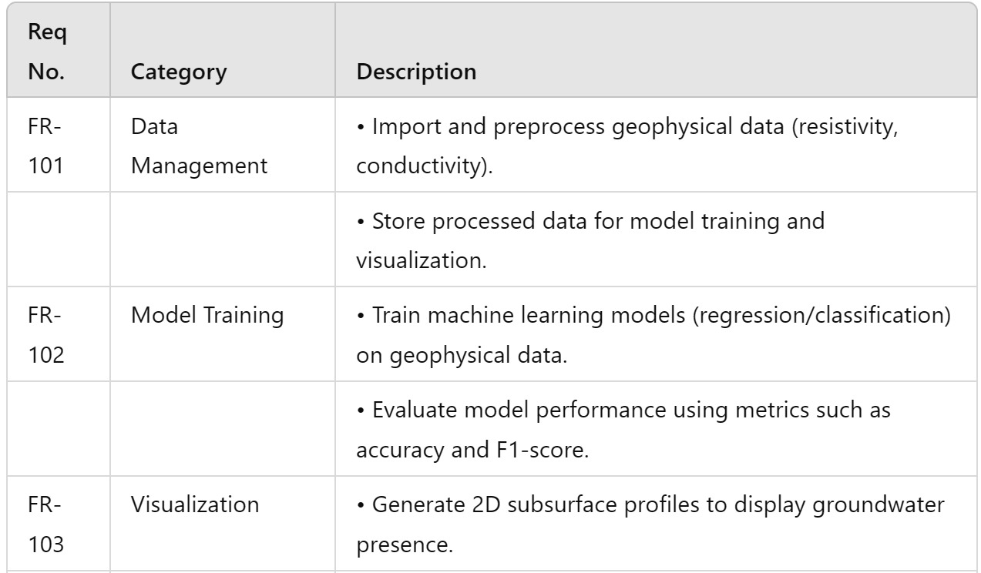

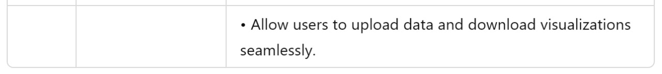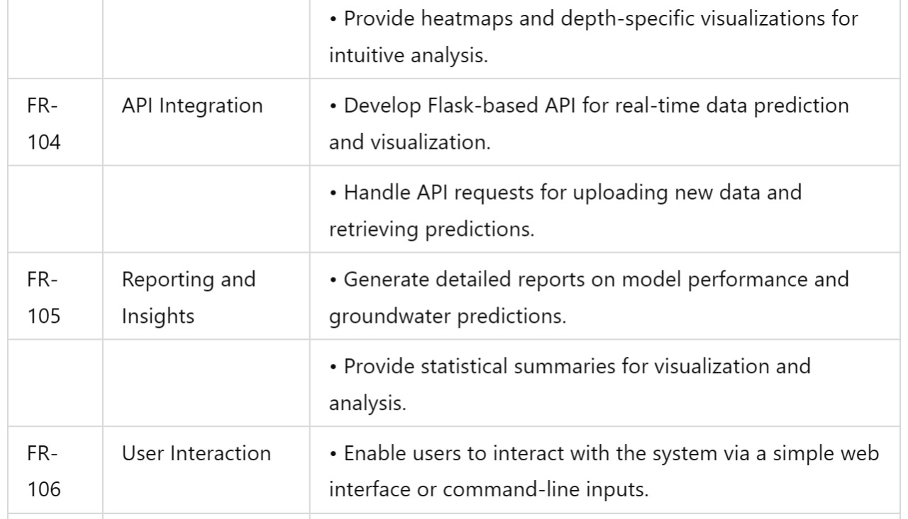

## 

## 3.3 Non-Functional Requirements

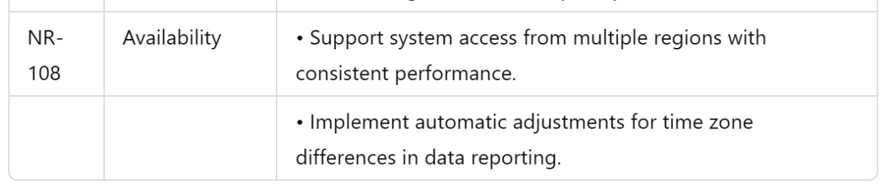

## 3.4 Feasibility Study

A feasibility study evaluates the practicality of the proposed system across three dimensions:

technical, financial, and operational.

**3.4.1 Technical Feasibility**

The technical feasibility of the Groundwater Level Prediction System is high, as it employs robust and widely used technologies. The system leverages Python for data processing and machine learning, utilizing libraries such as Pandas for data manipulation, Scikit-learn for model training, and Matplotlib for visualization. These tools are well-established in the data science community, offering reliable performance and extensive community support. The backend is built using Flask, which efficiently handles RESTful API requests, enabling smooth communication between data processing modules and user interfaces. For data storage, Pandas DataFrames are used locally, with the option to integrate Amazon S3 for managing larger datasets in the cloud. Deployment on platforms like AWS or Heroku ensures scalability, enabling the system to handle increasing workloads and users seamlessly. These proven technologies make the system technically viable and capable of meeting the project's demands.

**3.4.2 Financial Feasibility**

The project is financially feasible due to its reliance on open-source technologies, significantly reducing development costs. Key software components, including Python, Flask, Pandas, Scikit-learn, and Matplotlib, are free, eliminating licensing expenses. The main costs are associated with cloud hosting services like AWS or Heroku for deploying the system and managing user interactions. Additionally, storage solutions such as Amazon S3 offer cost-effective plans for handling large geophysical datasets. Since these costs scale with usage, the system remains affordable even as demand grows. This financial model ensures that the project can be developed and maintained within a reasonable budget, making it sustainable in the long term.

**3.4.3 Operational Feasibility**

The operational feasibility of the system is high, as it provides an automated and efficient solution for groundwater prediction. The system's workflows for data preprocessing, model training, and visualization are largely automated, reducing the need for manual intervention and streamlining operations. Its cloud-based infrastructure ensures that the system can handle multiple concurrent requests without performance degradation, providing a seamless experience for users. The interface is designed to be user-friendly, allowing non-technical users to upload data, view predictions, and interpret visualizations with ease. Maintenance requires a small team of data scientists and system administrators to oversee performance, apply updates, and incorporate user feedback. This ensures that the system remains operational and can be improved over time with minimal effort.

# CHAPTER 4: PROJECT PLANNING

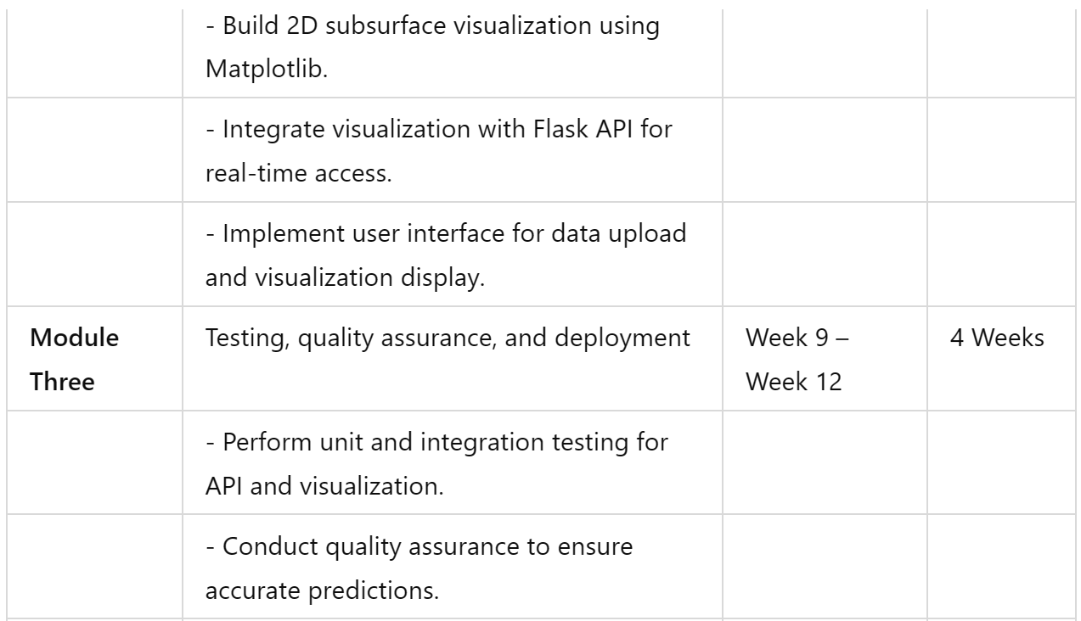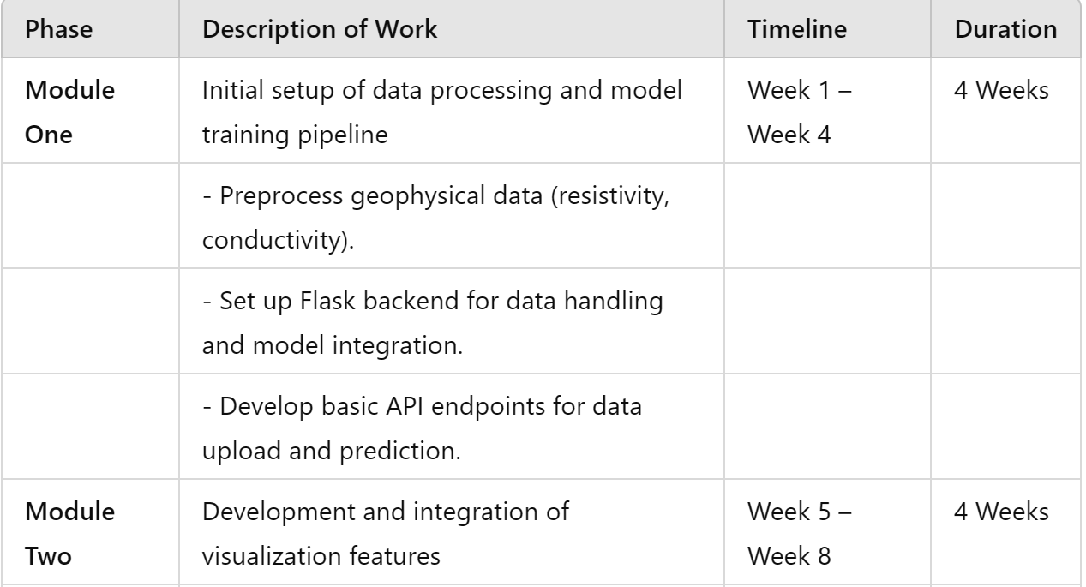

# 

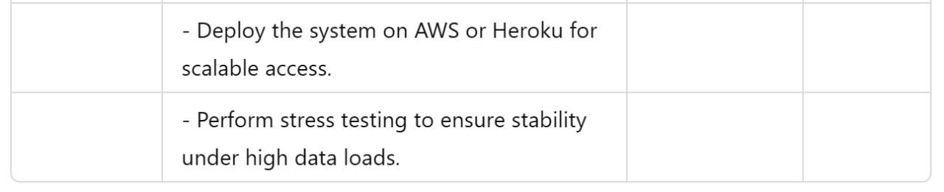

**Timeline Overview**

* Weeks 1–4: Module One – Backend setup, data preprocessing, and API development.
* Weeks 5–8: Module Two – Visualization development and integration with backend.
* Weeks 9–12: Module Three – Testing, quality assurance, and final deployment.

# CHAPTER 5: DESIGN

## 5.1 Introduction to UML

Unified modelling language (UML) is a general-purpose modelling language. The main aim of UML is defining a standard way to visualize the way a system has been designed. It is quite similar to blueprints used in other fields of engineering.

UML is not a programming language; it is rather a visual language. We use UML diagrams to portray the behaviour and structure of system. UML helps software engineers, businessmen and system architects with modelling, design and analysis.

## 5.2 UML Diagrams

Complex applications need collaboration and planning from multiple teams and hence require a clear and concise way to communicate amongst them.

Businessmen do not understand code, so UML becomes essential to communicate with nonprogrammer's essential requirements, functionalities and processes of the system.

A lot of time is saved down the line when teams are able to visualize processes user interactions and static structure of the system.

UML is linked with object-oriented design and analysis. UML makes the use of elements and from associations between them to form diagram. Diagram in UML can be broadly classified as:

1. Structural Diagrams: Capture static aspects or structure of a system. Structural Diagrams include- Component Diagrams, Objects Diagram, Class Diagrams and Deployment Diagrams.
2. Behaviour Diagram: Capture dynamic aspects or behaviour of the system. Behaviours diagram include- Use Case Diagram, State Diagram, Activity Diagram and Interaction Diagram.

### 5.2.1 Use Case Diagram

The purpose of a use case diagram in UML is to demonstrate the different ways that a user might interact with a system. Use case diagrams consist of 3 objects.

Actor: Actor in a use case diagram is any entity that performs a role in one given system. This could be a person, organization or an external system and usually drawn like skeleton.



Use Case: A use case represents a function or an action within the system. It’s drawn as an oval and named with the function.



System: The system is used to define the scope of the use case and drawn as a rectangle. This an optional element but useful when you’re visualizing large systems.

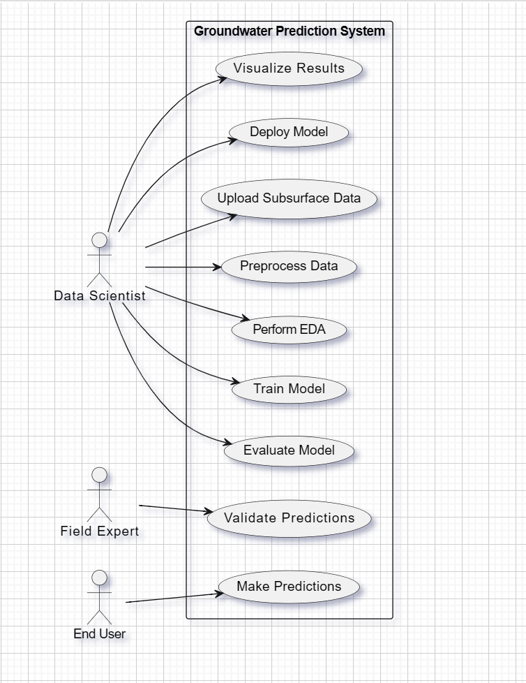

Figure: Use Case Diagram

### 5.2.2 Class Diagram

The class diagram is the main building block of object-oriented modeling. It is used for general conceptual modeling of the structure of the application. A class diagram in the Unified Modeling Language (UML) is a type of static structure diagram that describes the structure of a system by showing the system's:

* classes,
* their attributes,
* operations (or methods),
* And the relationships among objects.

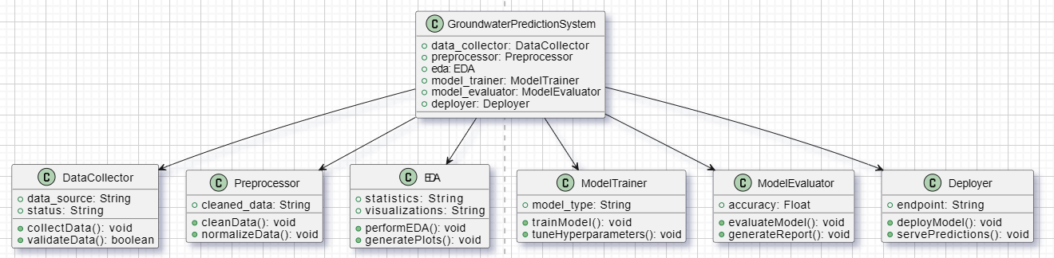

Figure: Class Diagram

**5.2.3 Sequence Diagram**

### A sequence diagram is a type of interaction diagram because it describe how-and in what order- a group of objects works together.

### Sequence diagram are sometimes known as an event diagrams or event scenarios.Sequence diagram are time focus.

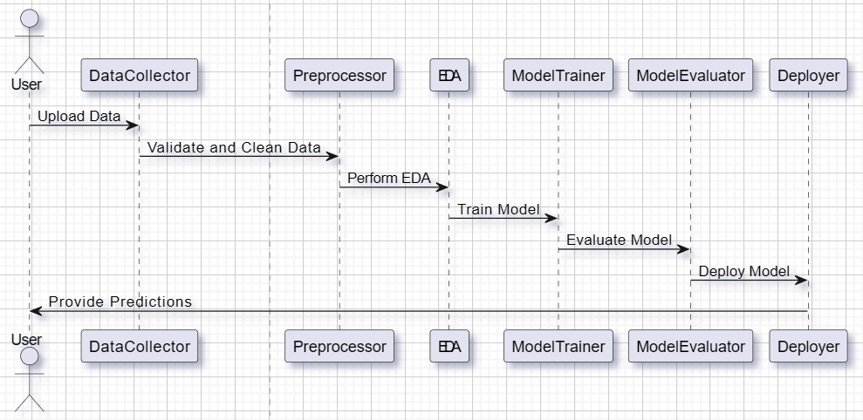

Figure: Sequence Diagram

#### 5.2.4. ER Diagram

ER Diagram is a visual representation of data that describes how data is related to each other. In ER Model, we disintegrate data into entities, attributes and setup relationships between entities, all this can be represented visually using the ER diagram. ER Diagrams contain different symbols that use rectangles to represent entities, ovals to define attributes and diamond shapes to represent relationships.

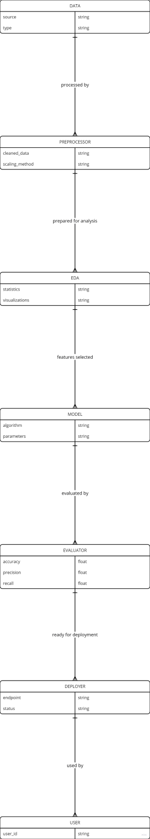

Figure: ER Diagram

**5.2.5 Activity Diagram**

An activity diagram portrays the control flow from a start point to f i n i s h point showing various decision paths that exist while the activity is being executed.

An activity diagram focuses on condition of flow and the sequence in which it happens. An activity diagram is a behavioral diagram i.e. it depicts the behavioral of a system.

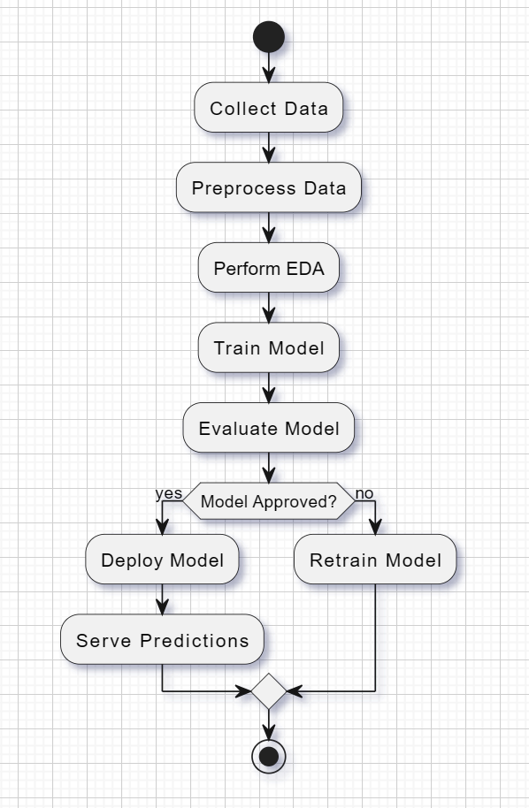

Figure: Activity Diagram

**4.4.6  Object Diagram**

An  object diagram  is a type of UML (Unified Modeling Language) diagram that shows a snapshot of the system at a specific point in time, focusing on the  instances of classes  (objects) and their  relationships . It visually represents how objects interact and are linked in the application, typically reflecting real-time data and helping understand the actual state of the system.

Unable to load the picture

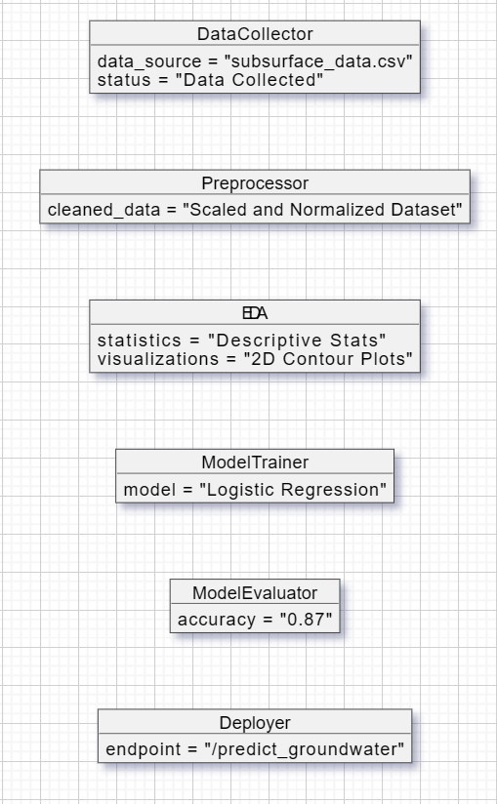

Figure: Object Diagram